SQL Week 2 Project- Andreas Wong
Task 2:
1) List the first 10 film titles in alphabetical order.
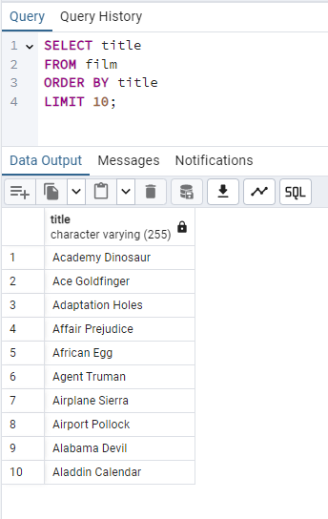
2) List the titles and release years of all films released in 2006, sorted by title.
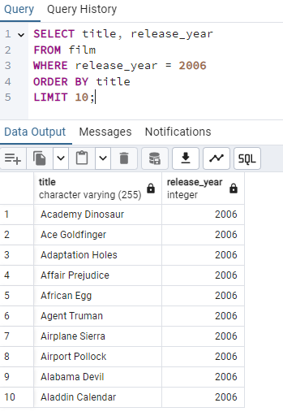
3) List the titles and ratings of all films rated PG or PG-13, sorted by title in reverse
alphabetical order.
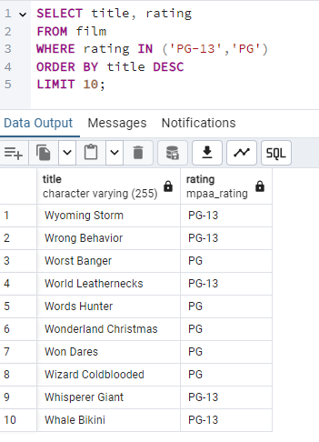
4) Show all the distinct film ratings in the database.
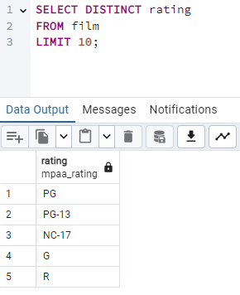
5) Find the total number of films in the database.
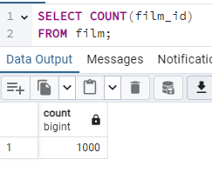
6) For each rating, show the number of films, sorted by the largest count first.
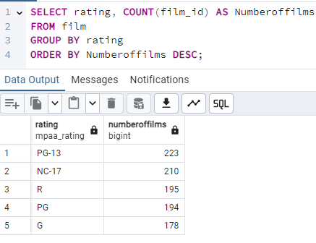
7) For each rating, show the number of films only if there are at least 200 films in that rating.
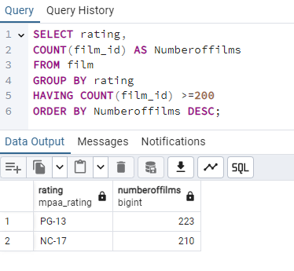

8) List the 10 longest films with their titles and lengths, starting with the longest.
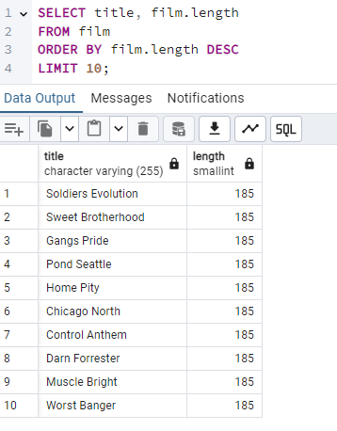
9) Show each film category and the number of films in it, sorted from largest to smallest.
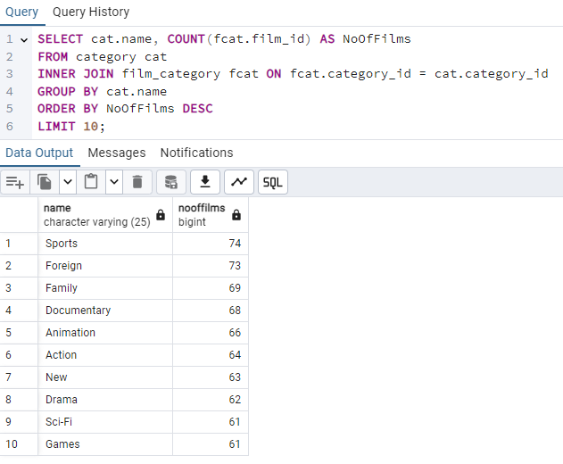
10) Show the 10 most frequently rented films with their rental counts.
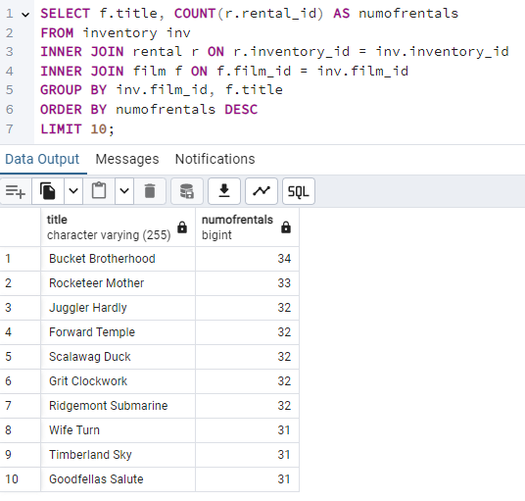
11) Show each customer’s full name and the number of rentals they have made, sorted
by highest number first.
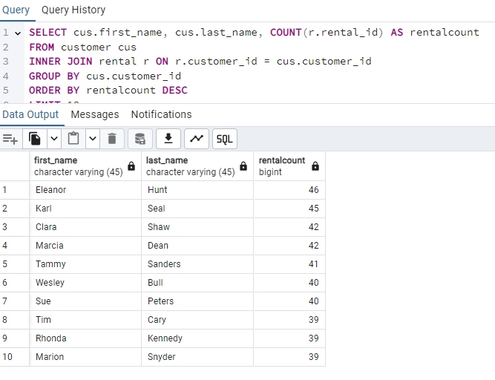
12) Show each customer’s full name, total amount paid, and number of payments they have made, sorted by the highest total paid first.
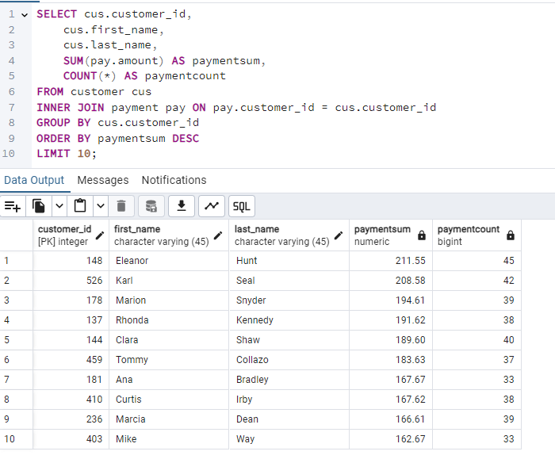
13) List all customers who live in Canada with their city and email address.
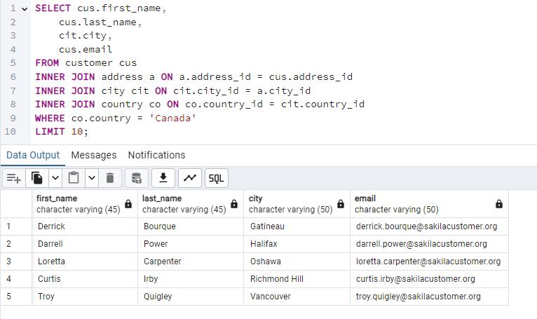
14) Show the average payment amount for each month, with the newest month first.
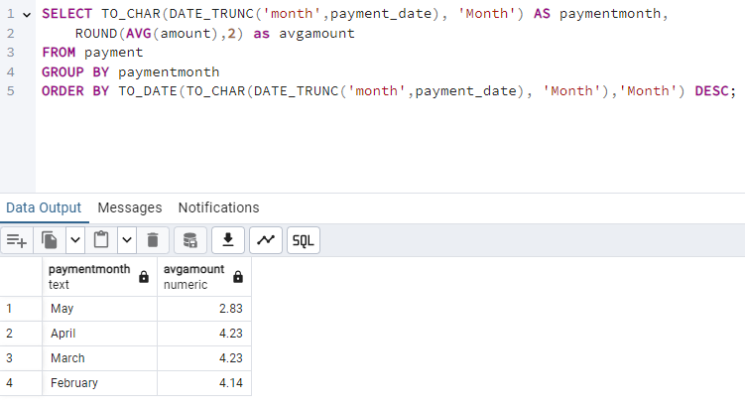

N

15) Show each film title and the number of actors in it, only if the film has at least 5 actors.
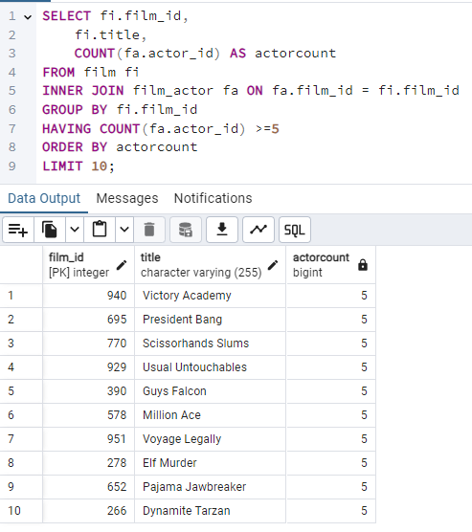
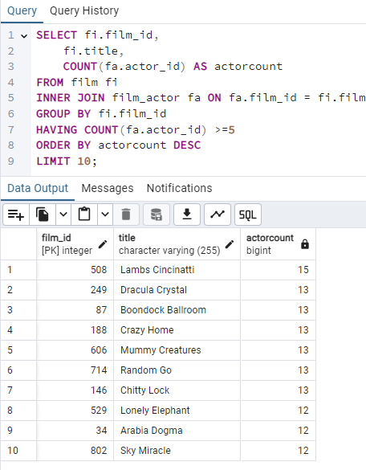
16) Show each store and the total payment amount it has processed, sorted from highest to lowest.
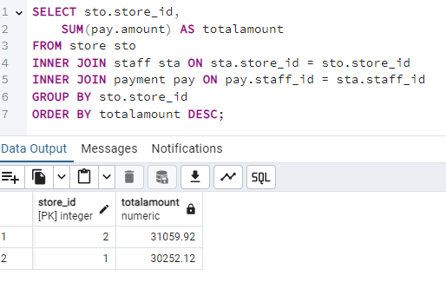

Task 3:
1) Find the top 5 customers by total payment amount
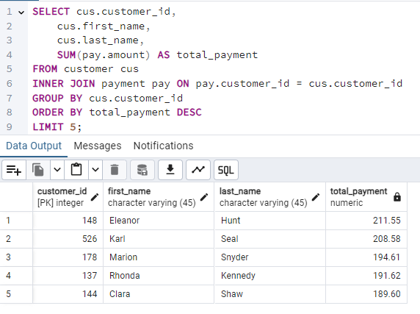
2) Identify the top 3 most rented film categories
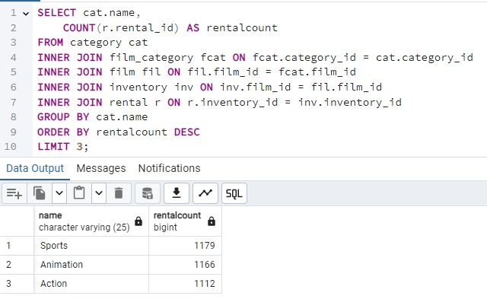
3) Calculate the average rental duration per film category
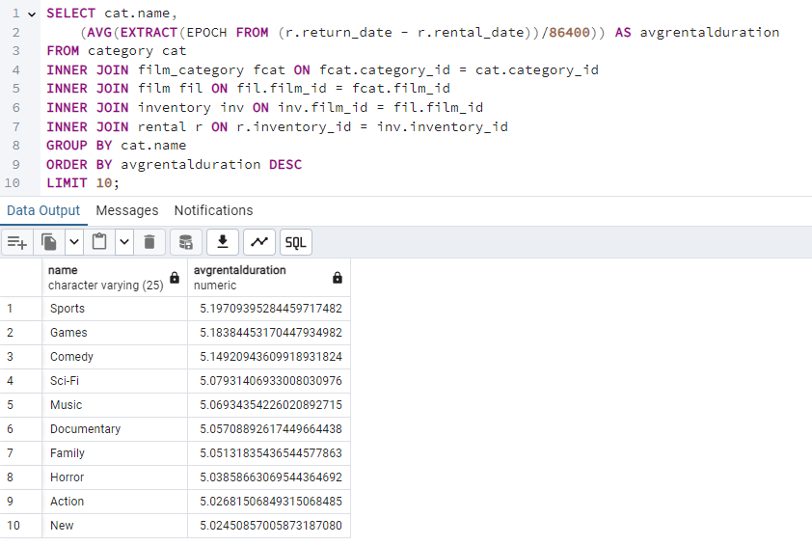

4) For each store, show monthly revenue for the most recent year in the dataset
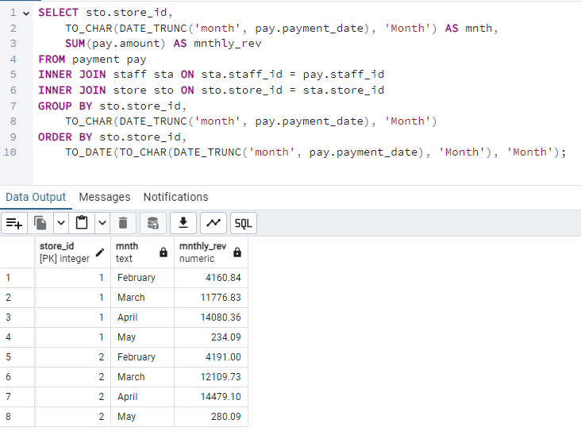
5) Find films that were never rented
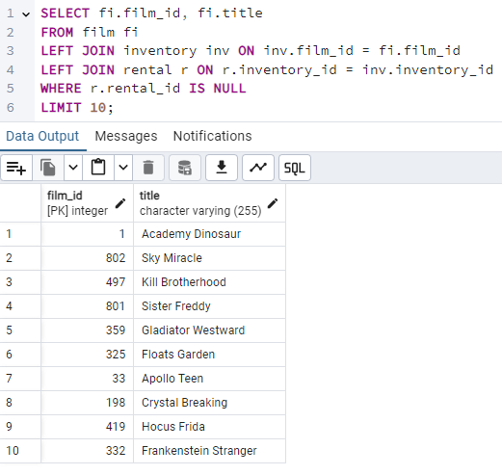
6) List customers who have spent over $100 in total
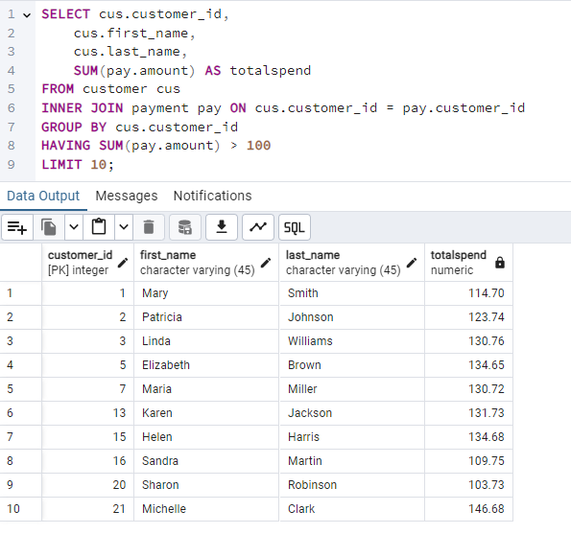

7) Show the staff member with the highest total payments processed
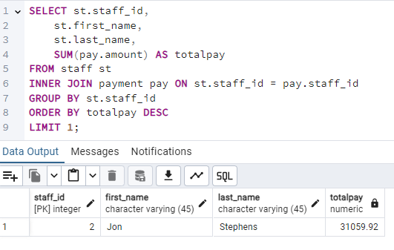
8) For each category, show average film length, only including categories with above-
average length
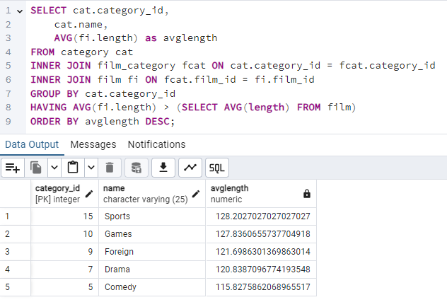
(I assume with a window function we could actually have the average length of all films in a column next to the avglength column to more easily verify)

